# Topic: Survival Analytics

**Instructions:**

Please share your answers filled in-line in the word document. Submit code separately wherever applicable.

Please ensure you update all the details:

**Name: _____________**

**Batch Id:**

**Topic: Survival Analytics**

**Hints:**

1. **Business Problem**
   1. **What is the business objective?**
   2. **Are there any constraints?**
2. **Work on each feature of the dataset to create a data dictionary as displayed in the below image:**

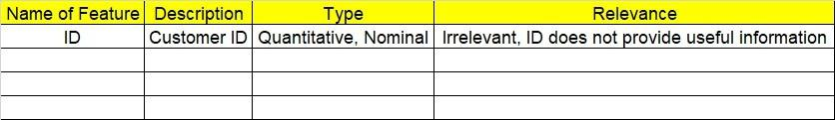

**2.1 Make a table as shown above and provide information about the features such as its Data type and its relevance to the model building, if not relevant provide reasons and provide description of the feature.**

1. **Exploratory Data Analysis (EDA):**
   1. **Summary.**
   2. **Univariate analysis.**
   3. **Bivariate analysis.**
2. **Model Building**

**4.1 Build the model on the scaled data (try multiple options).**

**4.2 Perform survival analytics on the given datasets.**

**4.3 Briefly explain the model output in the documentation.**

1. **Write about the benefits/impact of the solution - in what way does the business (client) benefit from the solution provided?**

**Problem Statement:**

The following dataset contains patient ID, follow up, event type, and scenarios. Build a survival analysis model on the given data.

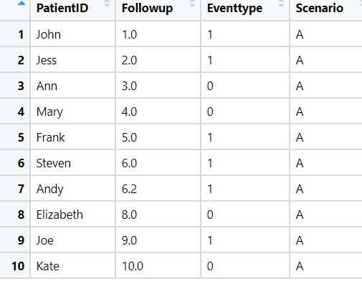

**Problem Statement: -**

ECG of different age groups of people has been recorded. The survival time in hours after the operation is given and the event type is denoted by 1 (if dead) and 0 (if alive). Perform survival analysis on the dataset given below and provide your insights in the documentation.

